Z

Zombie Hunter

Game Design Document

University of the West of Scotland

Computer Game Development

Contents

Game Overview 3

Core Objective 3

Expected Experience 3

Platform 3

Desktop PC 3

Mobile 3

Development Tools 3

Concept Art 4

Final Art Environment and Description 6

Game Structure 9

Sprites/Sprite Animation 9

Character 9

Souls 9

Keys 9

Guns 9

Health Hearts 9

Level Map 10

Canvas 10

Scoreboard 10

Name Entry system 10

Market Research 10

Monetization model 10

Competitors and Price Comparison 10

What sets this project apart? 11

Reason 1 11

Reason 2 11

Reason 3 11

Reason 4 11

Core Gameplay Mechanics 11

Player Mechanics 11

Enemy/Zombie Mechanics 11

Player Shooting Mechanics 11

Pistol 11

Machine Gun 11

Shotgun 12

Scoring Mechanics 12

Play Area Mechanics 12

Timer 12

Level Map 12

Health 12

Keys 12

Guns 12

Ascension Area/Level complete area 12

Audio 13

Video 13

Zombie Hunter Game Design Document

# Game Overview

Zombie Hunter is a 2D game for both desktop pc and mobile devices and classed in the top-down shooter genre. The theme of the gameplay will be Sci-fi/fantasy with a human main character and zombie characters as enemies. The setting for the scenes will be outdoor with walls, also with doors that require specific keys to unlock and three different gun variants to help on your quest.

## Core Objective

The aim of the game is to kill a set number of zombies and collect their freed souls to open the ascension portal. so that you can ascend to the next Level. You will only have a set time to do so before the portal closes.

## Expected Experience

I would expect the players to experience a survival style adventure where there is the constant threat from the ensuing zombie horde also with need to find keys to unlock doors. This constant horde keeps the user in a panicked state making it a little more tricky to find the keys under pressure.

# Platform

The game will be available for play in both desktop PC’s and mobile devices and will be automatically detected, dependant of the device used. Currently this does not fully support IOS due to full screen restrictions.

## Desktop PC

The desktop version of the game will allow the player to control the player and traverse menu systems using the mouse and keyboard.

## Mobile

The mobile version of the game will start with a Virtual analogue stick for player movement/aim and a single button for firing. The feel on mobile will be quite different due to the physics inertia added to allow the user to turn and partially strafe whilst gliding on inertia. Menu systems and buttons will be navigated using touch controls

# Development Tools

The game was created using the Phaser 2 API in conjunction with JetBrains WebStorm for editing the HTML and JavaScript files. Google chrome was used as the output layer from WebStorm with the use of node.js to configure USB debugging on my mobile phone. This allowed me to turn off the page cache for the development process.

# Concept Art

I investigated a few games to try and get some ideas for my own game, a screenshot of each game is shown below with a title showing the games name.

#### When It Hits The Fan

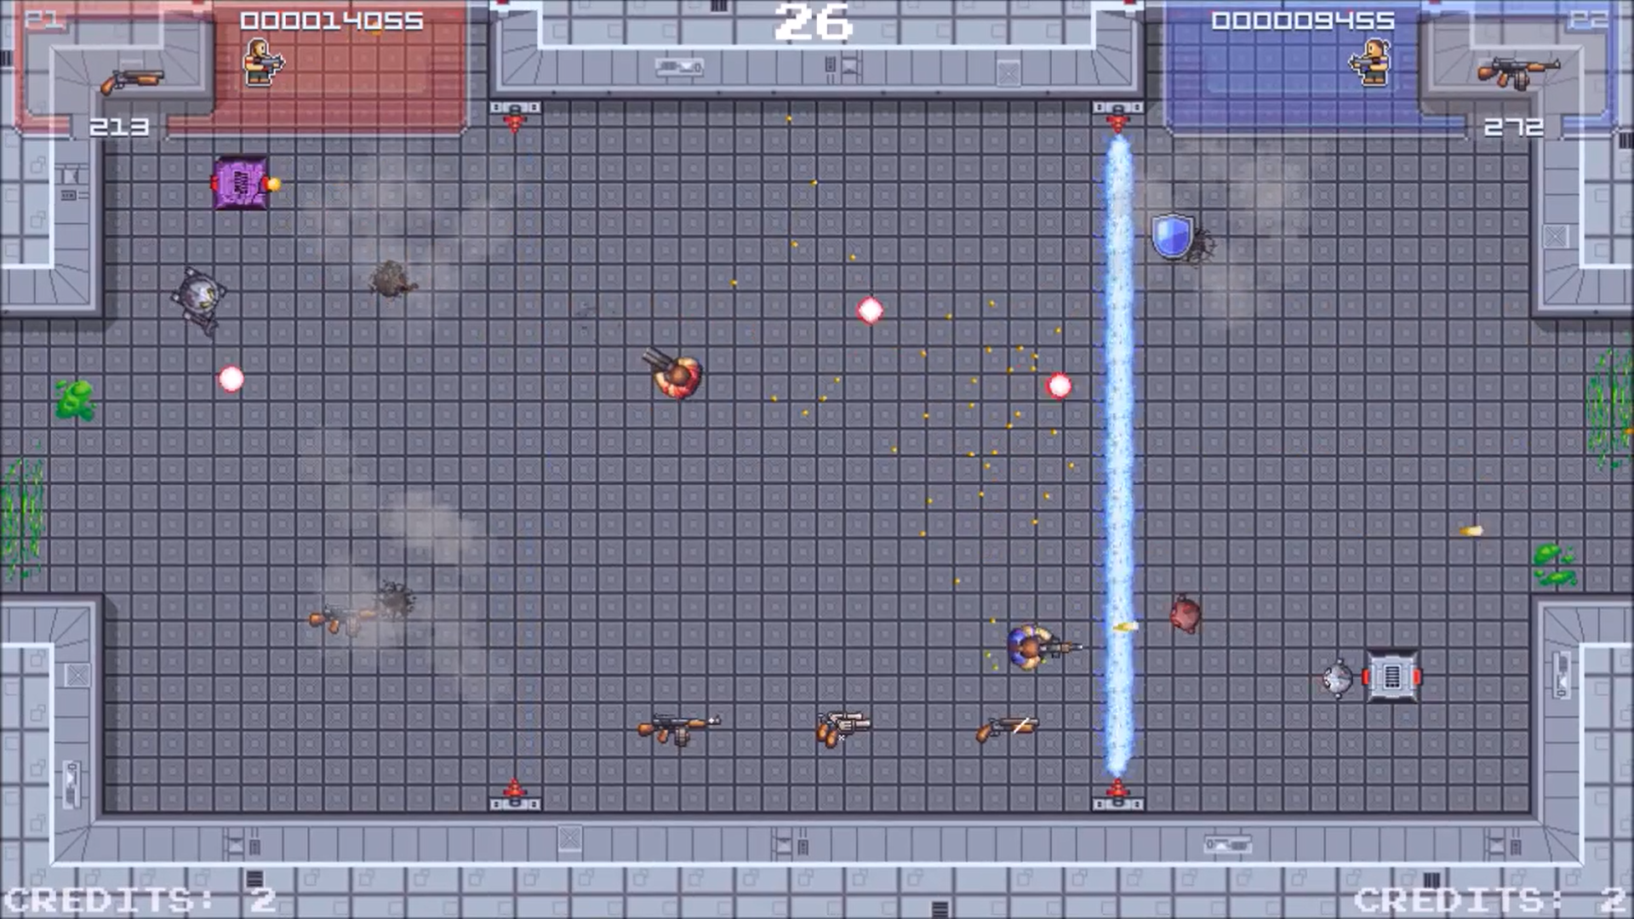

#### Final Days

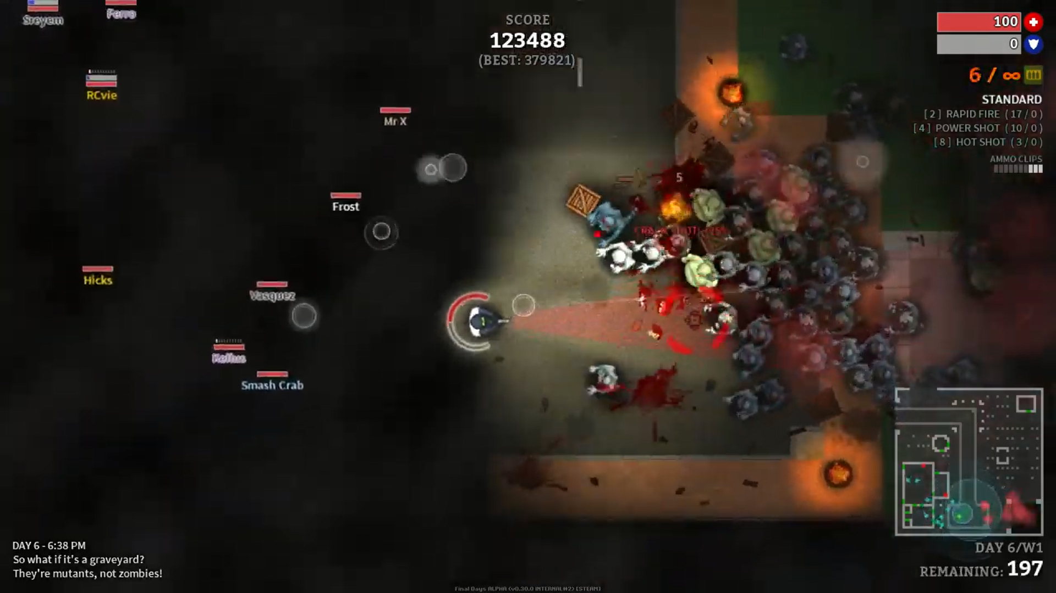

#### Survive

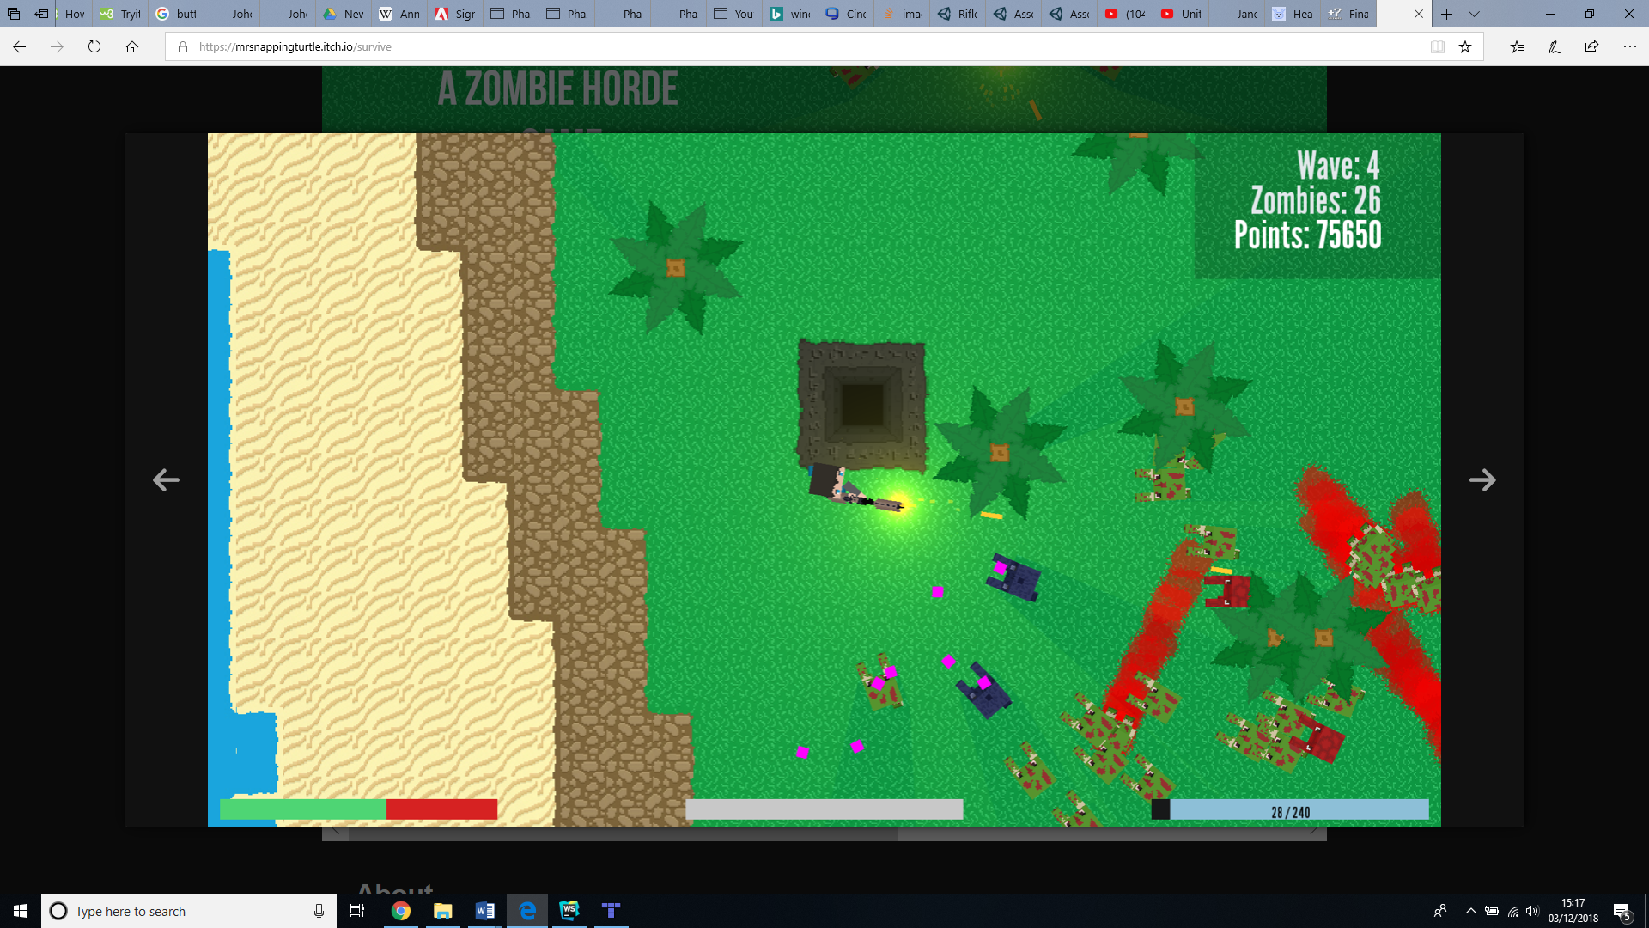

#### Ranger

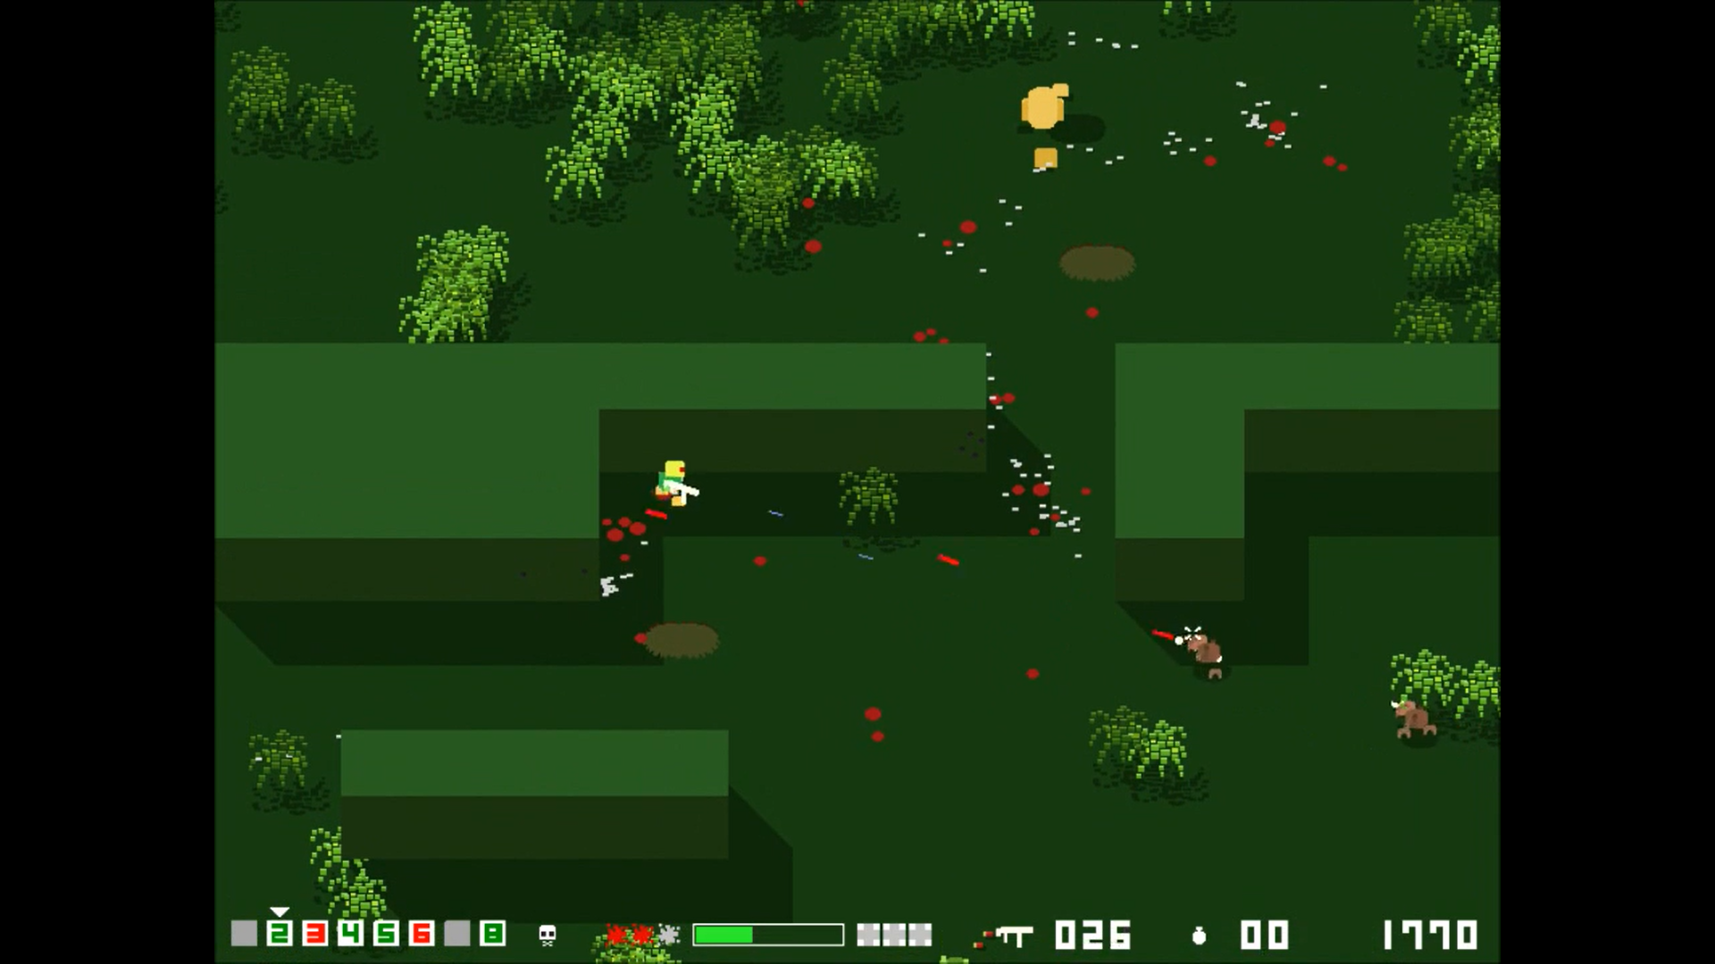

# Final Art Environment and Description

The final art for the game is shown with descriptions of each different object in the scene. The various sections of the game are presented in this format below;

Health Pickup Player Health Bar Soul Pickup Zombie/Enemy

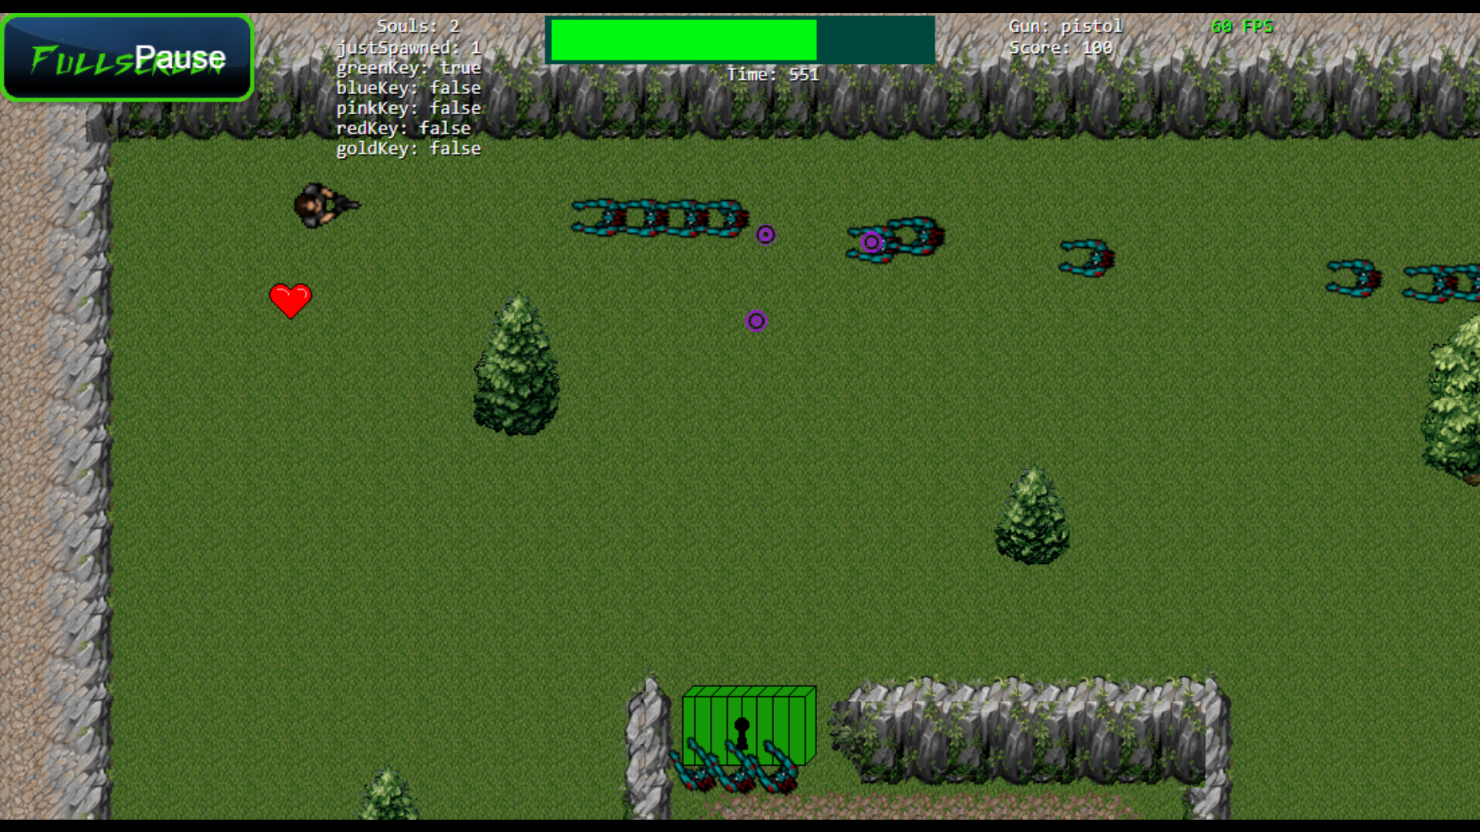

Mountain/Wall Door Tree/Obstacle

Key Debug Soul Count Game Timer Present Gun Score

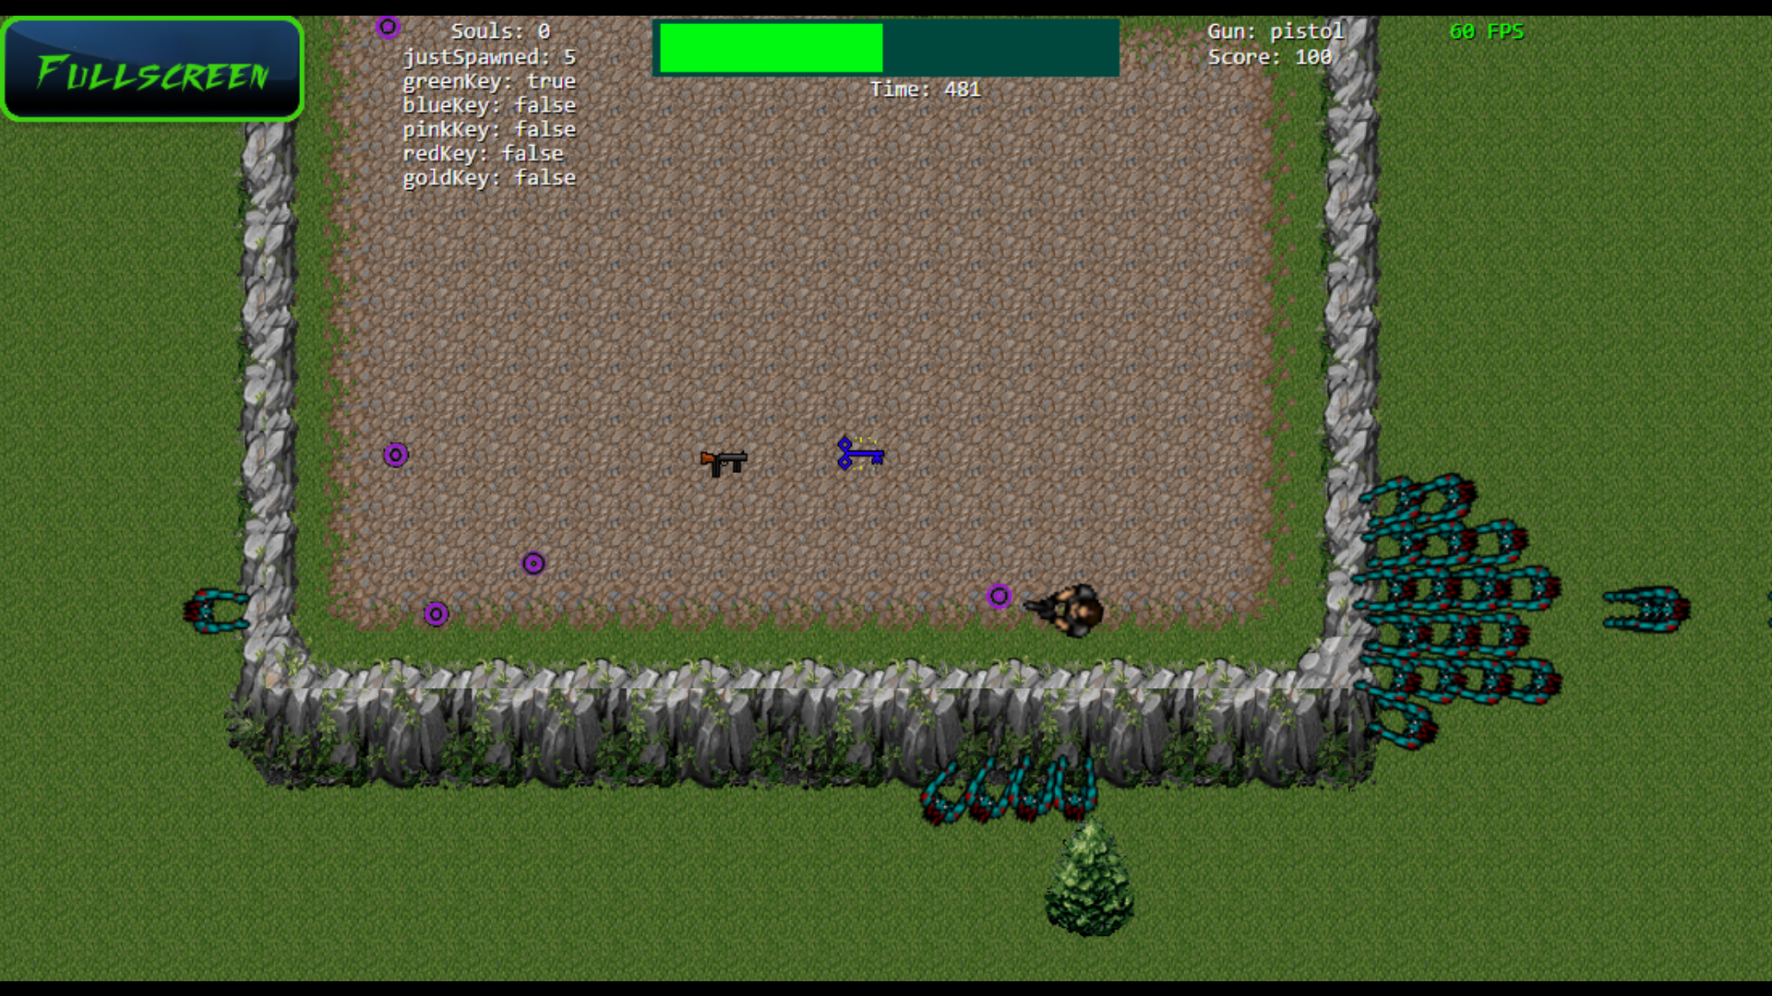

Gun Pickup Key Pickup

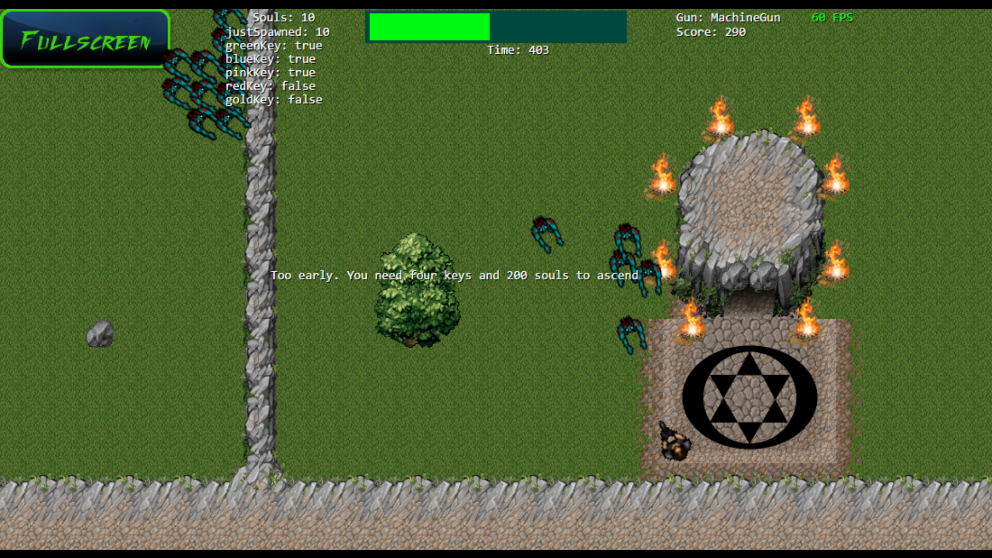

Ascension Message Ascension Area

Virtual Keyboard Clear Button Name Entry Submit Button

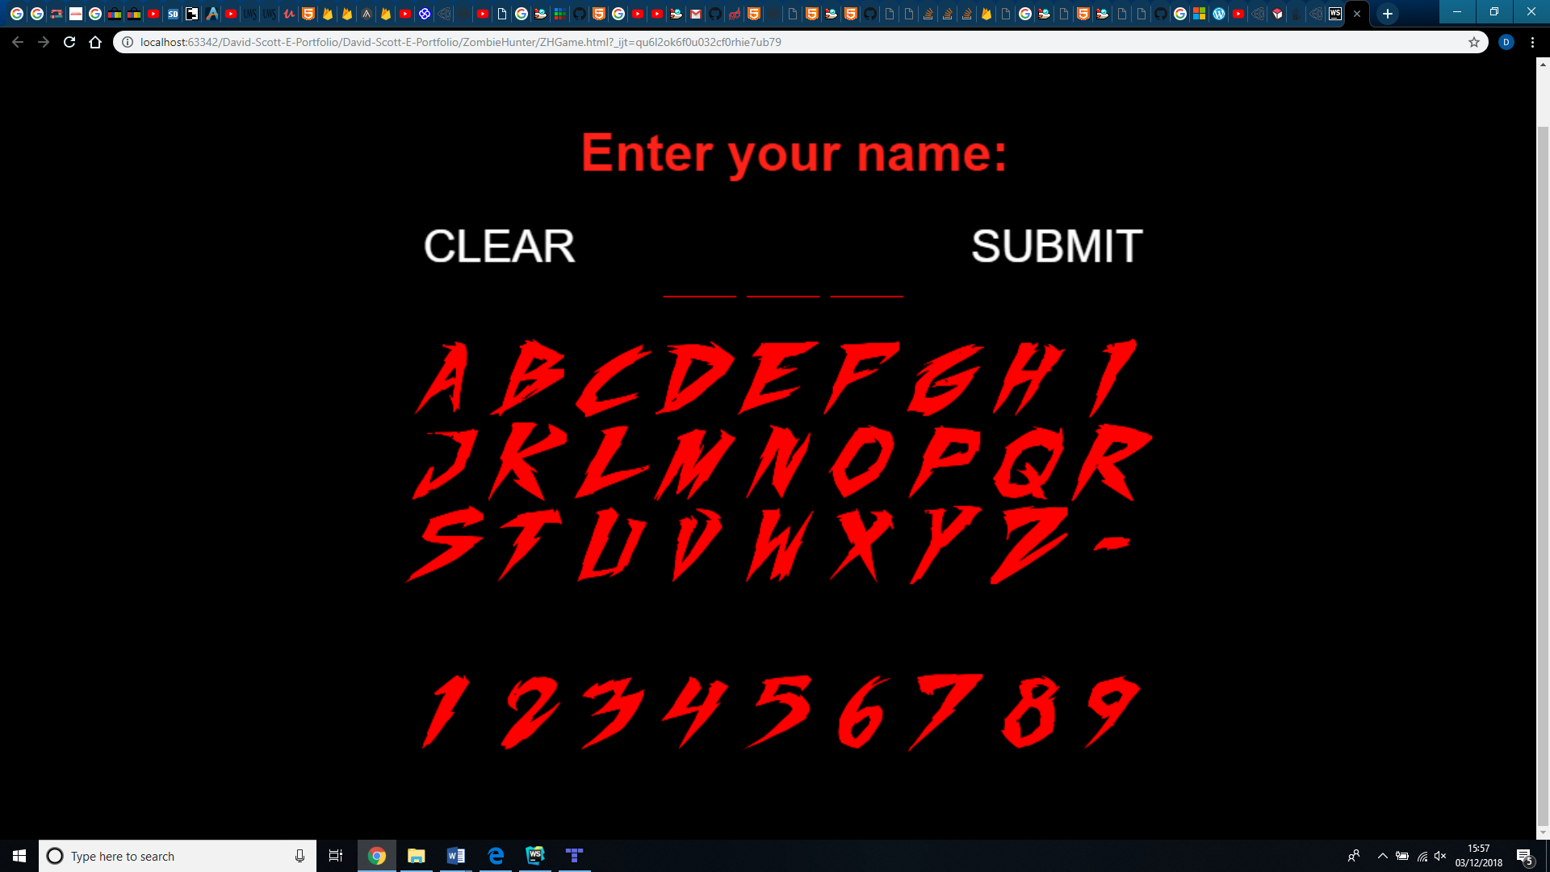

Mountains/Walls Trees Rocks

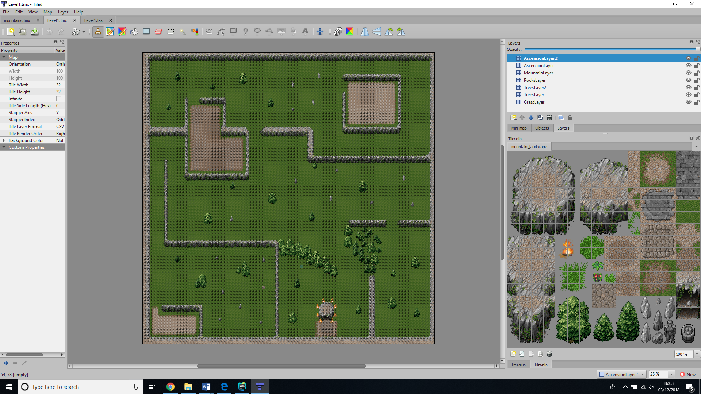

Enclosed Area Ascension Area Grass/Walkable Area

# Game Structure

The game will be deployed with Firebase hosting using a standard website with the main output displayed on a HTML5 Canvas and developed using the Phaser 2 API. There will also be a top five scoreboard that will be hosted using Firebase Realtime Database. A virtual analogue stick asset was also purchased and implemented to handle the mobile control mechanism.

## Sprites/Sprite Animation

All sprites are edited and refined using Piskel from https://www.piskelapp.com/

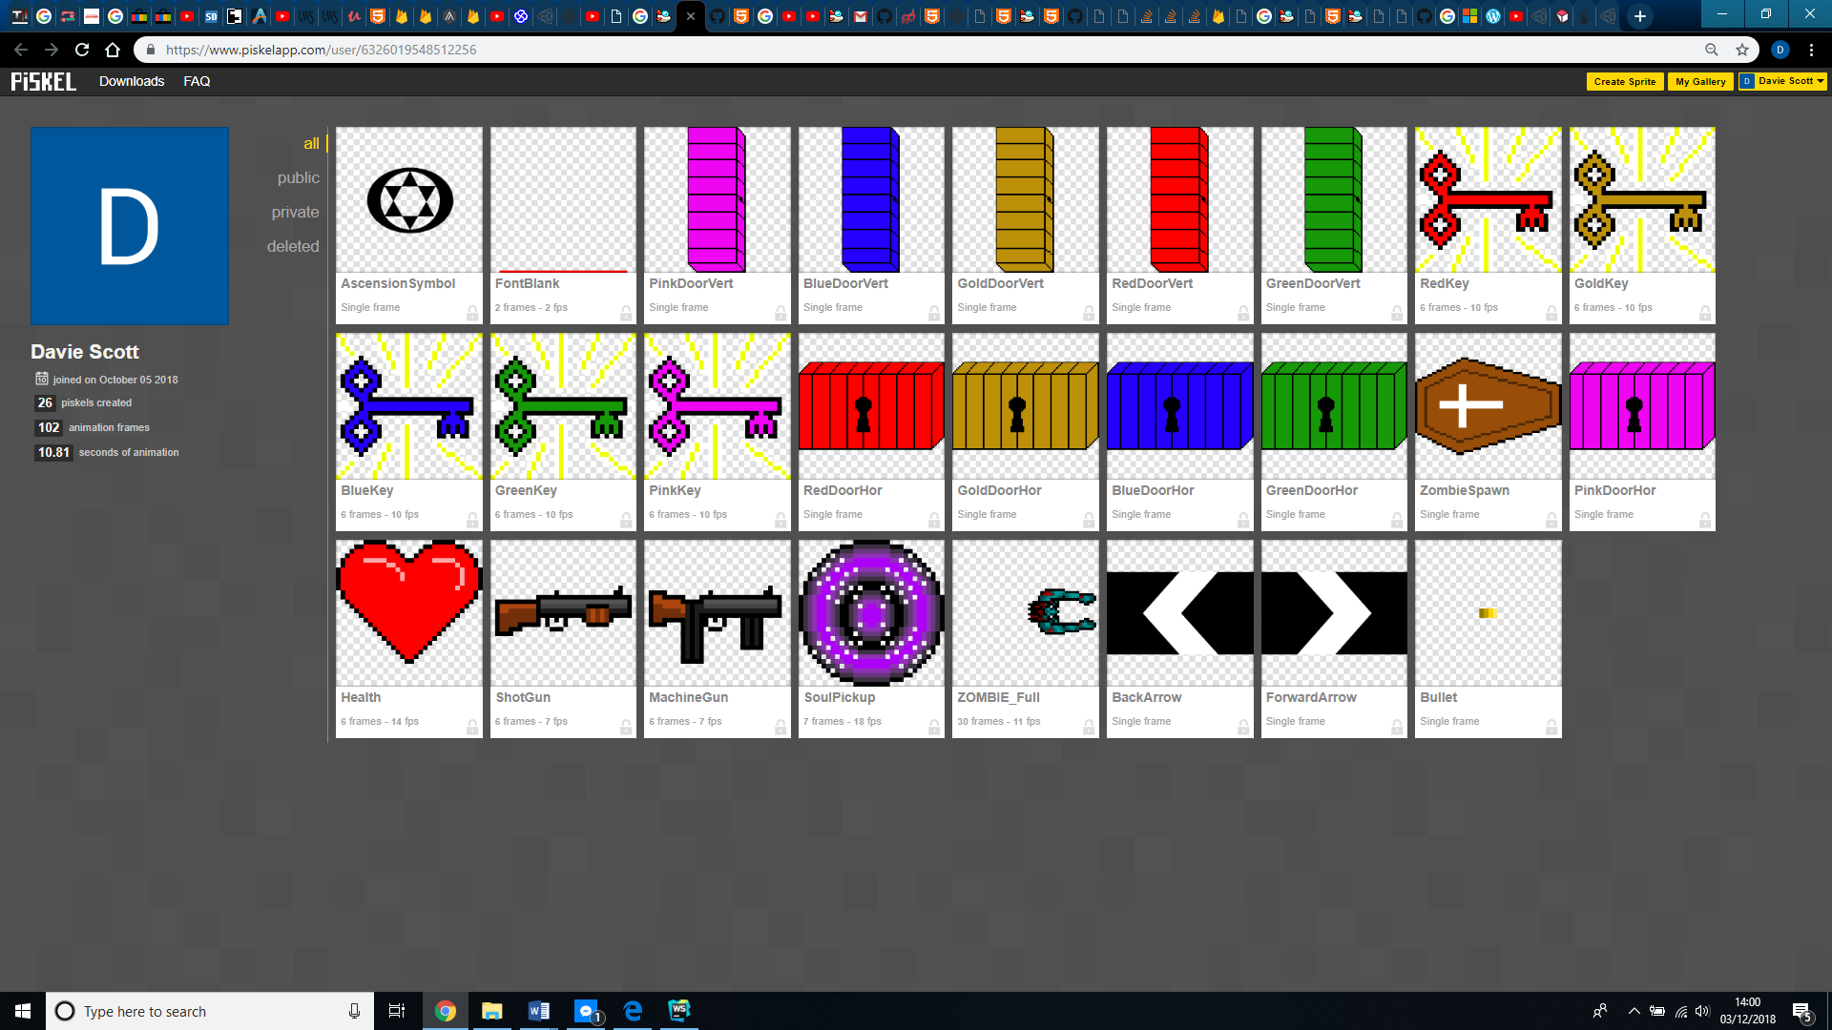

### Character

Both the player and zombie sprites are in the form of a sprite sheet with various animation sequences such as gun fire and recoil on the player and walk and blood splatter death animations for the zombies

### Souls

The souls are simple orb shaped pickups with a pulsating ring animation using a sprite sheet.

### Keys

The keys are animated by bobbing up and down in place with a pulsating aura flashing from them using a sprite sheet.

### Guns

The guns are animated by bobbing up and down in place using a sprite sheet.

### Health Hearts

The health hearts are animated by bobbing up and down in place using a sprite sheet.

## Level Map

The map was created using a tileset imported into the program Tiled.

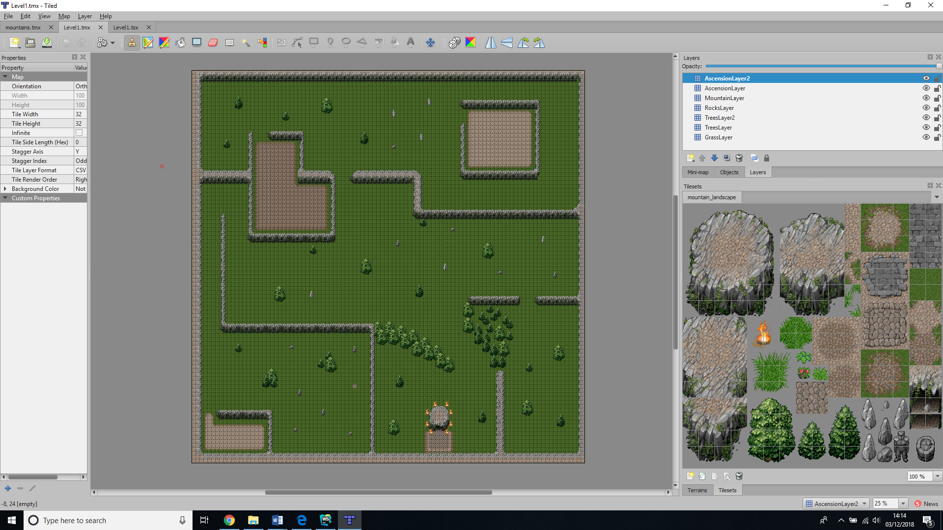

## Canvas

The main game displayed on the canvas will automatically be set to full screen when the game is played giving a larger visible play area. This unfortunately does not work properly on IOS due to their crippling restrictions.

## Scoreboard

The scoreboard will be utilised by integration to firebase database allowing the top five scorers names to be held with the related score. The name entry will only consist of three characters to reduce size, time and easier consistent formatting of the score table.

## Name Entry system

If a player manages to gain a high enough score to reach the high score table, they will presented with a virtual keyboard that will allow them to enter their name. On completion the name and relative score will be displayed and stored on the high score table.

Market Research

## Monetization model

There are currently have no plans to add a monetization model to this game. The game will be free to play for the first few iterations to find if there is a viable market. In the future there may be consideration to adding a monetization model for character customization and extra map packs/levels.

## Competitors and Price Comparison

* When It Hits the Fan – £6.99(steam) from <http://www.heartfeltgames.org/>
* Final Days - £5.79(steam) from +7 Software <http://plus7software.com/finaldays/>
* Survive – (name your price) from <https://mrsnappingturtle.itch.io/>
* Ranger – Free from <https://foppygames.itch.io/ranger>
* Gauge of Rage - £2.89 from steam by Dave Myers, WubsGames

# What sets this project apart?

## Reason 1

The game is available to play on both desktop PC and mobile devices and automatically sets up to the detected device.

## Reason 2

The player does not have to accumulate a total score to win. They must also collect souls from downed zombies which also adds points to their total score and souls collected count.

## Reason 3

The player does not simply have to play through the level by shooting enemies to progress. There will be a touch of adventure as the player must find and collect keys to gain access to different areas.

## Reason 4

High scores will be registered on Firebase realtime database and reset every week to allow new players to attain acknowledgement.

# Core Gameplay Mechanics

## Player Mechanics

The players movement will be controlled using the WASD for up, down, left and right on PC and virtual stick on mobile. They will also be able to aim their gun using the mouse on PC and whatever direction they are facing on mobile via the virtual stick. The players health is shown by a health bar. Each time an enemy zombie contacts with the player the health bar will be reduced and will be able to be replenished by collecting a heart pickup. If the health bar reaches zero you die, which will end your current game session.

## Enemy/Zombie Mechanics

The zombies are set to continually track the player and aim to walk to the players location providing no obstacles are in their way to stop them. When the zombies reach the player and the collision boxes collide the players health is reduce at a constant rate and the zombies stop walking forward and start move back and forth slightly as if they are feasting on our hero. They will also continue to spawn at random locations on the level map until a set number are present in game (100 zombies)

## Player Shooting Mechanics

There will be three different types of gunfire from three different guns available.

### Pistol

The player will start off the level with a pistol that fires one bullet accurate towards the mouse pointer each time you click the fire button.

### Machine Gun

There will also be a machine gun that can be picked up and will automatically fire bullets continuously whilst the fire button held down, and these bullets also travel towards the mouse, but will not be as accurate at longer range as there is a small random spread variation.

### Shotgun

The final gun that can be picked up will be a shotgun that fires a wide spread of 3 bullets towards the mouse pointer each time the fire button is pressed.

## Scoring Mechanics

The player will have a total score that can be incremented via collecting certain pickups, unlocking doors or killing zombies. 10 points will be added to the total score every time the player opens a door, kills a zombie, picks up a soul or picks up a key. The only exception will be when the player picks up the final gold key, as 50 points will be awarded for this.

## Play Area Mechanics

### Timer

As time progresses the game timer will reduce by 1 every second and if it reaches zero before the player ascends then they will die meaning game over.

### Level Map

The map will be divided up and blocked off with Mountains and trees as walls with a few rocks and trees dotted around as obstacles.

### Health

The health pickups will disappear when collected only by a player who has lost some health from their health bar. They can simply be collected when a player walks over them allowing both the player and health’s collision boxes to collide.

### Keys

The key pickups will disappear when collected by a player picks who them up and displays in the GUI status bar at the top of the screen. They can simply be collected when a player walks over them allowing both the player and key’s collision boxes to collide.

### Guns

The gun pickups will disappear when collected by a player picks who them up and displays in the GUI status bar at the top of the screen. They can simply be collected when a player walks over them allowing both the player and gun’s collision boxes to collide.

There will also be doors that block access to certain areas and can be unlocked via the use of a key. The door will disappear when the player obtains the correct key and collides with the corresponding door

### Ascension Area/Level complete area

There will be an ascension area where the player will be able to ascend to completion of the level. Should the player enter the area they will complete the level, or a message will be displayed if the player tries to enter without the required amount of souls collected. For this iteration this will complete the game when ascending. In future releases the ascension will lead the player to new levels.

# Audio

The game has a wide range of SFX clips and the Sounds were all separately sourced from <https://freesound.org>. At the current version I have no sounds for the zombie characters other than death sounds as I had reached the projects time constraints, however, for future versions I would consider using a range detection system where only zombies within a set distance from the player could make a groaning sound.

# Video

The video was created using OBS <https://obsproject.com/> to record my gameplay. This was then converted from .flv format to mp4 using VLC player <https://www.videolan.org/vlc/index.en-GB.html> and finally edited within Adobe Premiere.